Sculpting a Model with Mirror Symmetry
- Select “Quad Draw” from the “Modeling Toolkit”
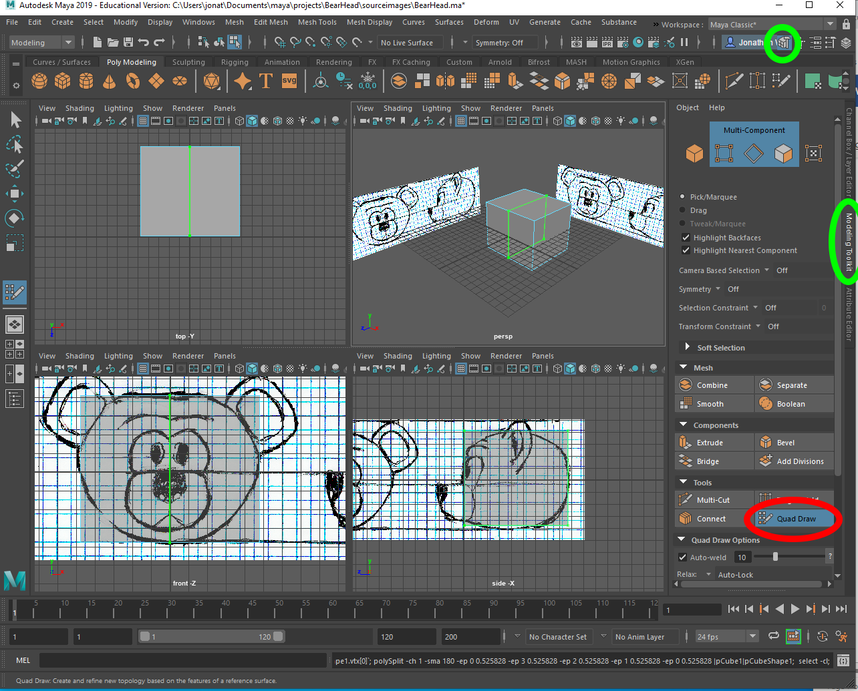
- Hold down Ctrl and Left click on the top edge to split the cube around the center along the X axis
- Turn on “Snap to Grid” (the magnet next to the grid at the top)
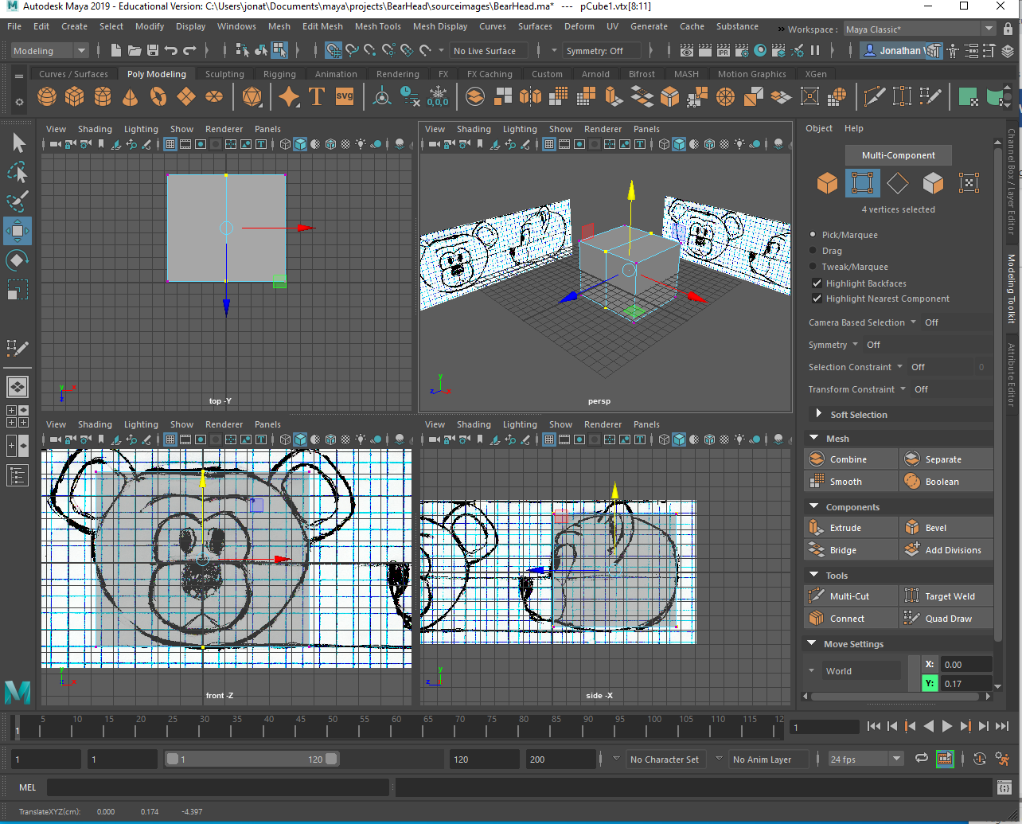
- Right Click on the model, and select “Vertex”
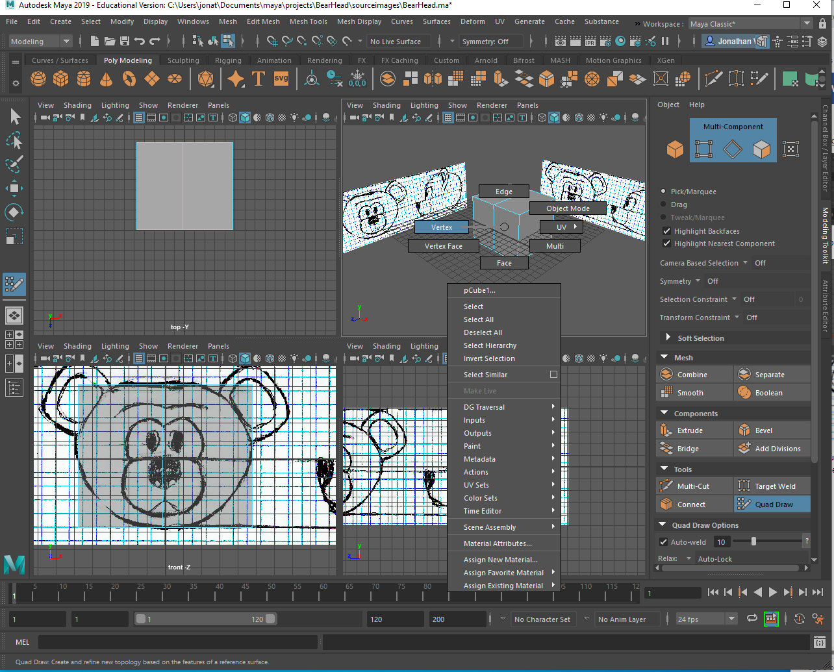
- Click on the “Selection Tool” from the tool bar on the left
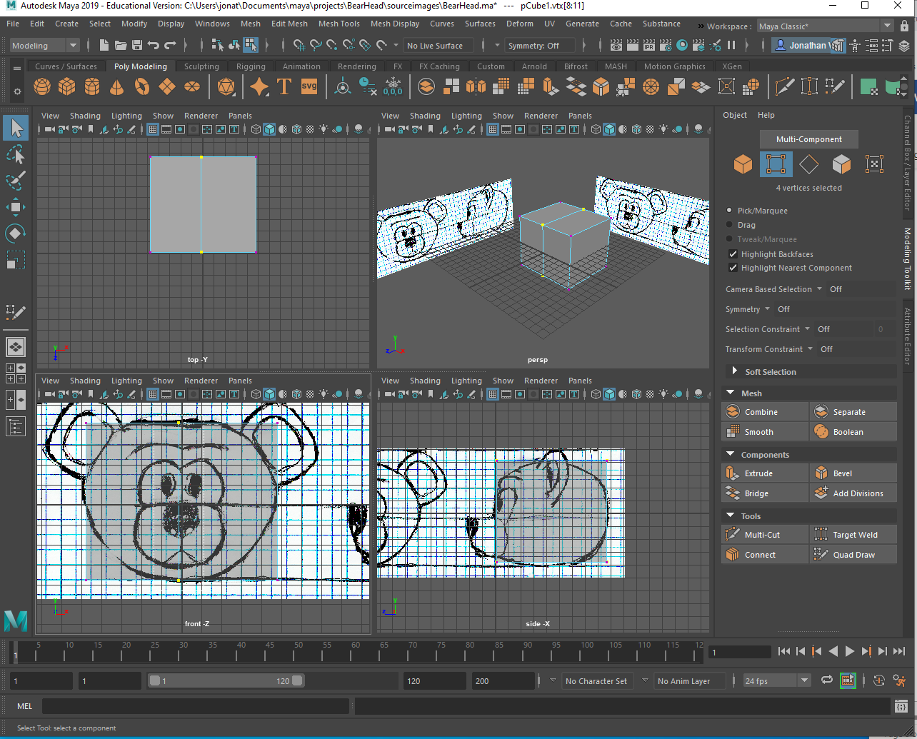
- Marquis select the middle 2 vertices in the Front View
- Double Click on the “Move Tool”, the tool settings will come up
- Open the “Move Snap Settings” and deselect “Retain Component Spacing”
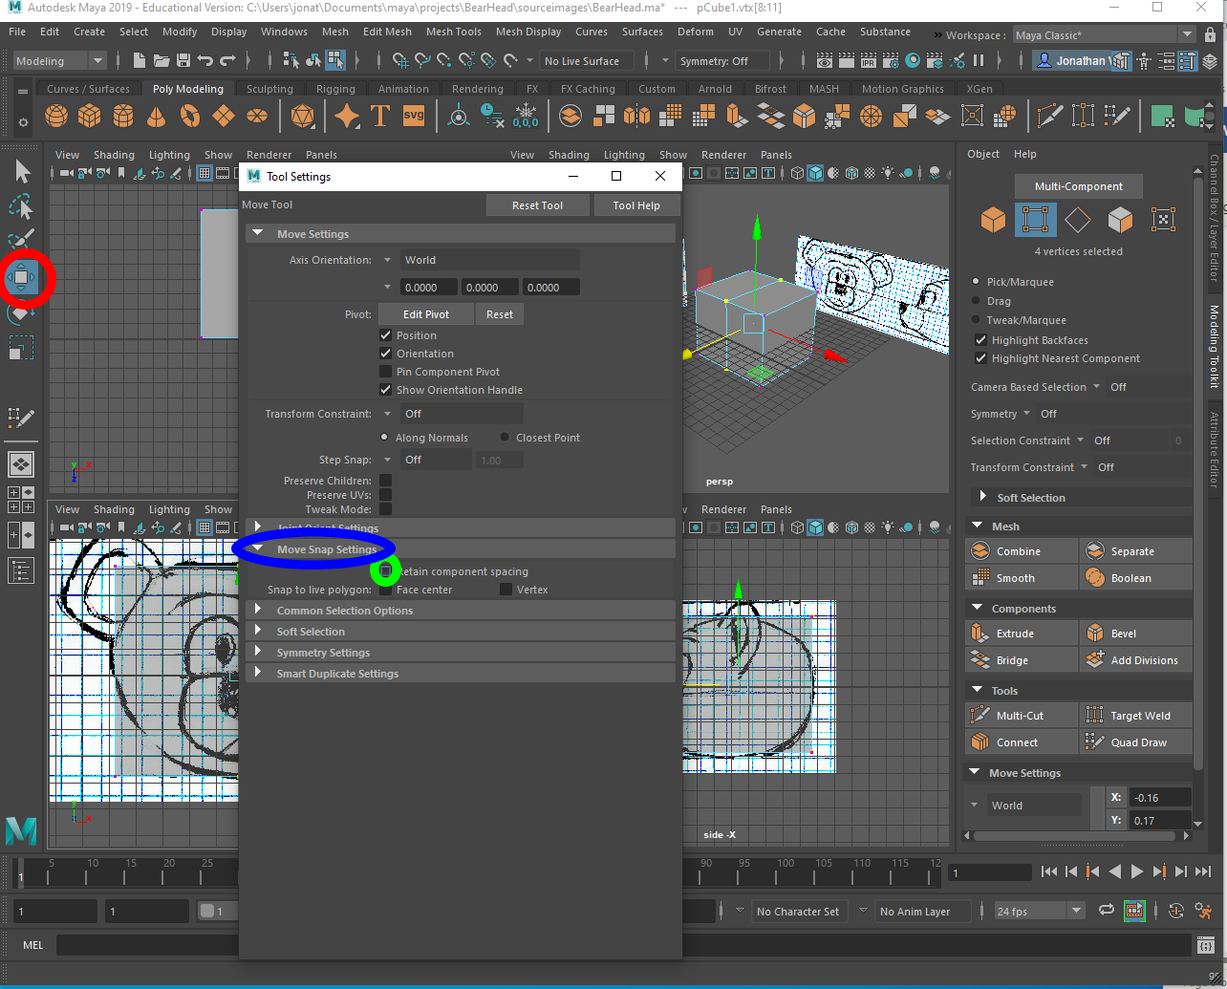
- Move the X axis handle cone (do not grab the middle of the move tool), and move the vertices to the left one square and back to the 0 axis. (This step aligns the vertices along the middle of the object)
- Turn off snapping to grid (click the magnet next to the grid again), and select the “Quad Draw” tool again (see step 1).
- Drop an edge loop near the border of the important features on the right half of your model from the front view (in this model I dropped a loop for the top of the nose, bottom of the nose, right side of the nose, bottom of the snout, and right side of the snout.
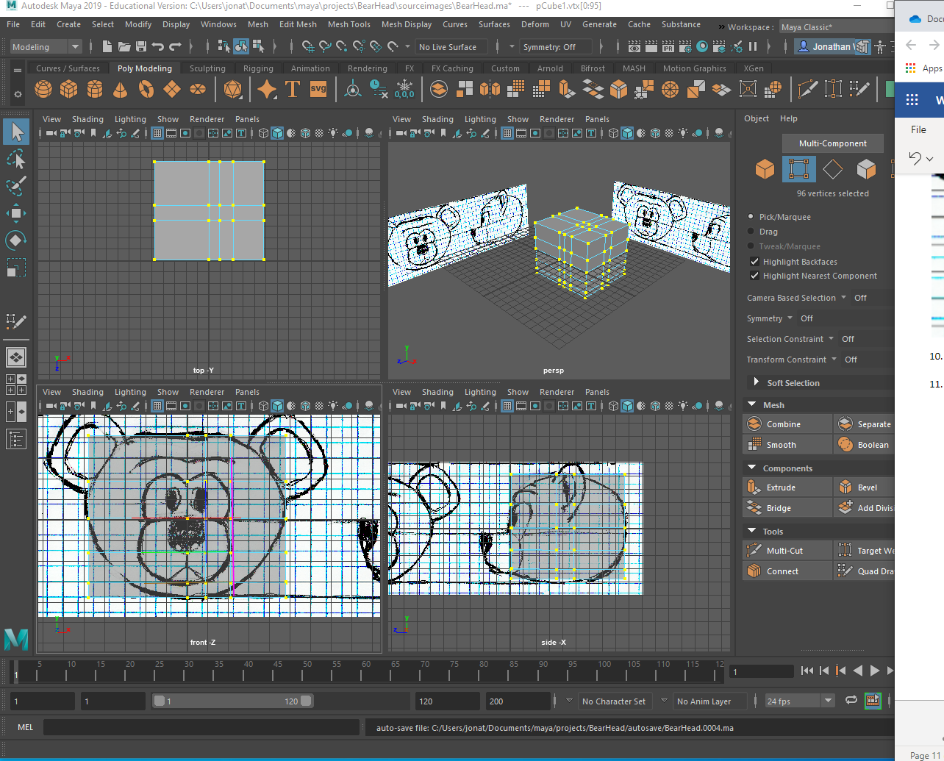
You do not need to worry about the left side of the model because we are going to model ½ the head and mirror the other side
- Do the same for the side view (here I just added a loop for the front and back of the ears because I am extruding the snout.
- Move the vertexes to match the front view (do not translate the vertexes along the center on the x axis, only the Y axis)
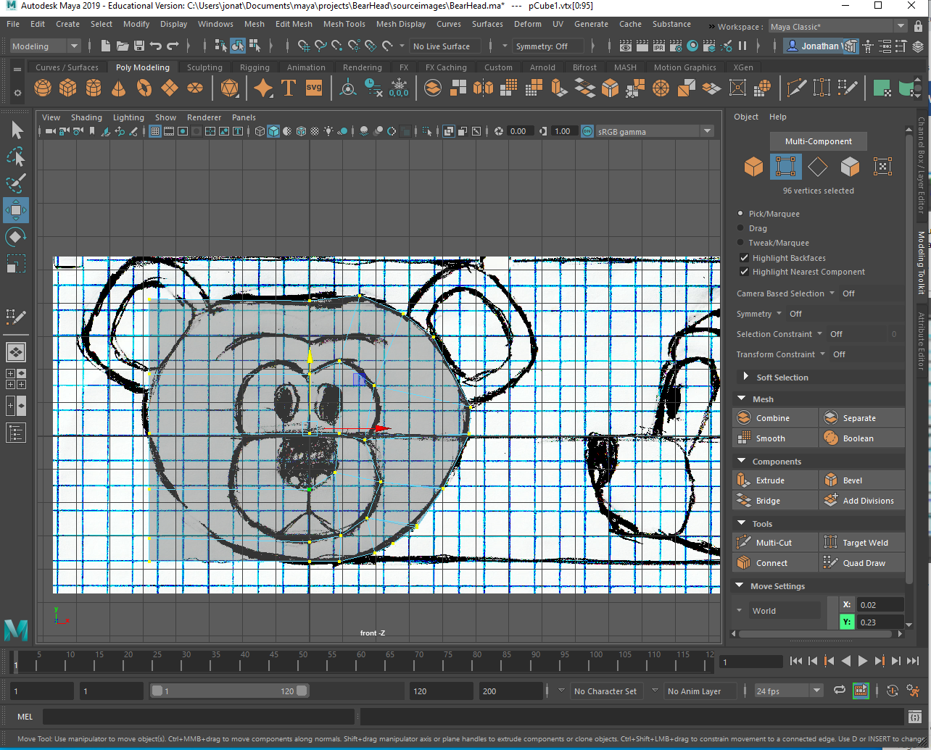
- Do the same for the side view (I am not worried about the nose or the ears yet because I will extrude there). Right now, I am just trying to get the vertexes in the front and side views inside the general shape without worrying about the parts that stick out because I will do that after I extrude.
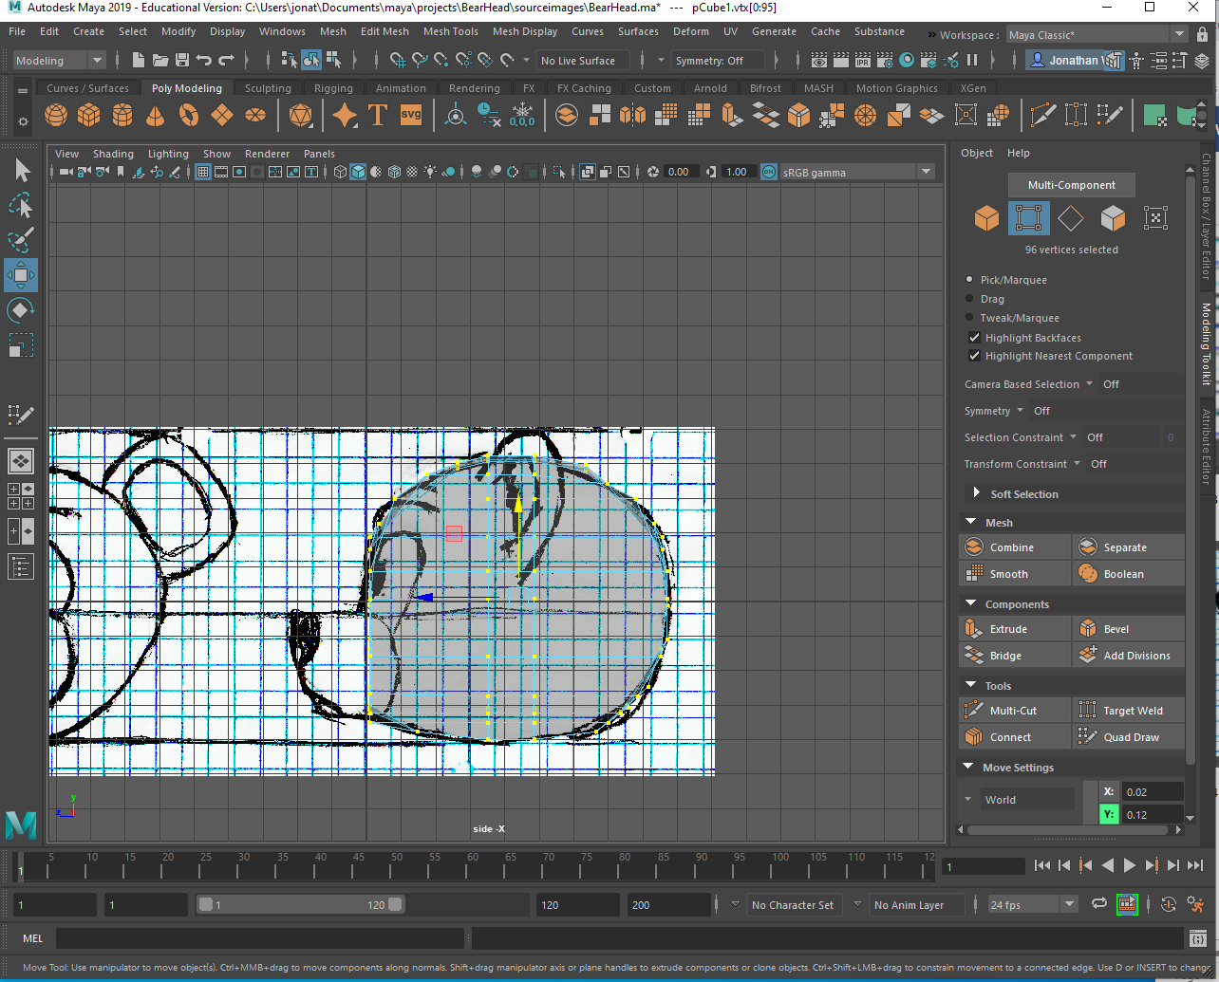
- Now I am going to go into the perspective and the top view and move any vertexes that poke out or make the shape look boxy (I am only worried about the right side of the head).
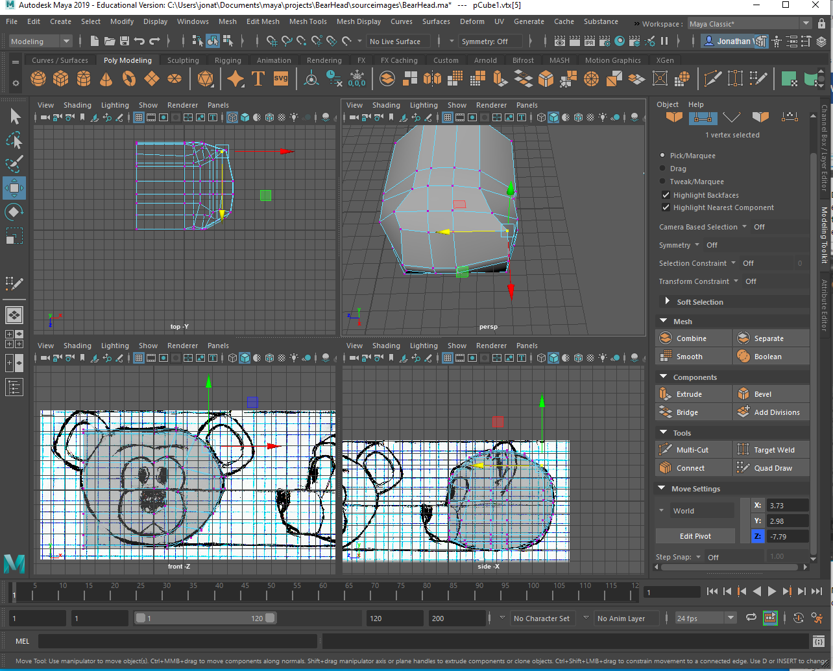
- Right click on the model and select the faces that will make up the snout
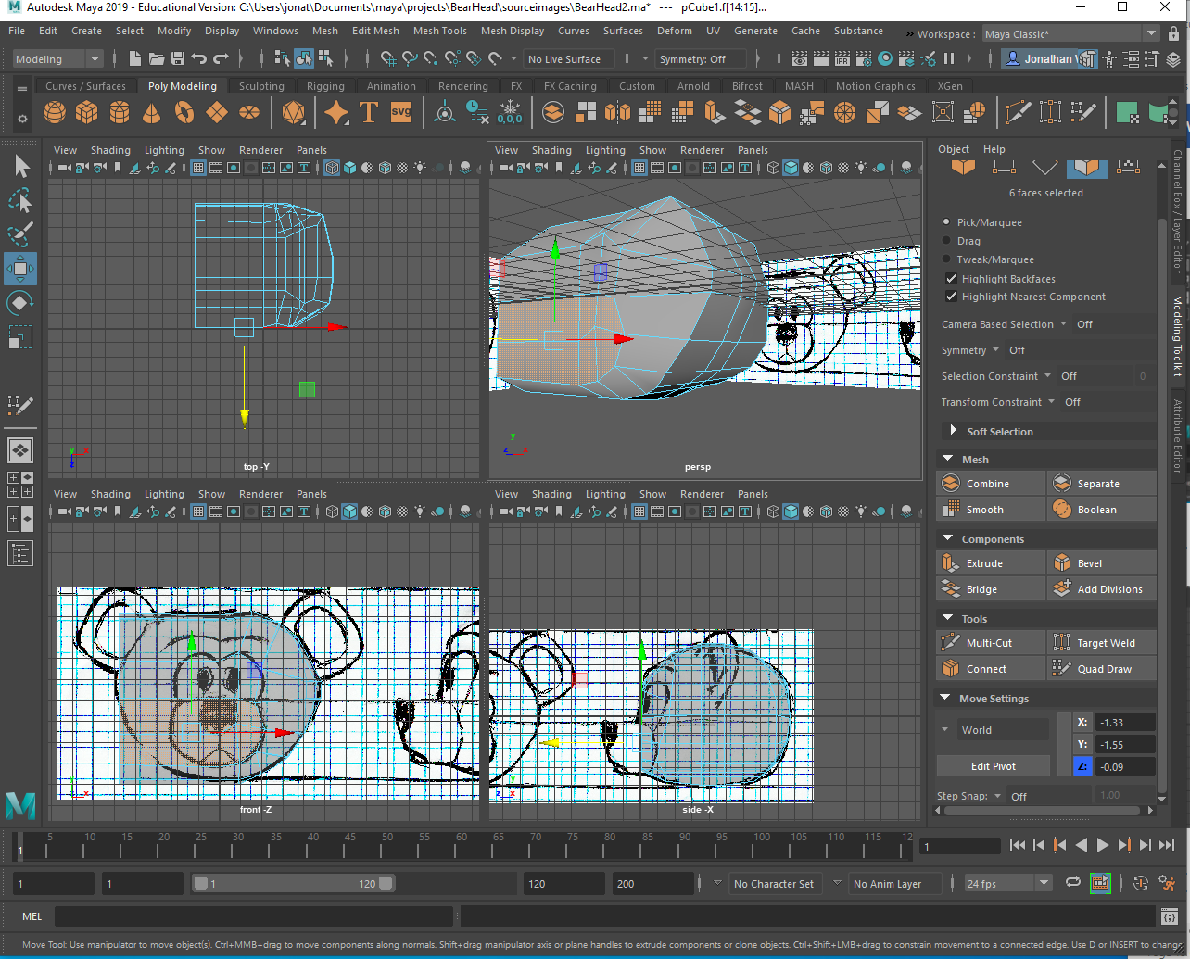
- Click the extrude tool (From the Shelf, Edit Mesh -> extrude, or Ctrl = E), and make sure “Keep faces Together” is On
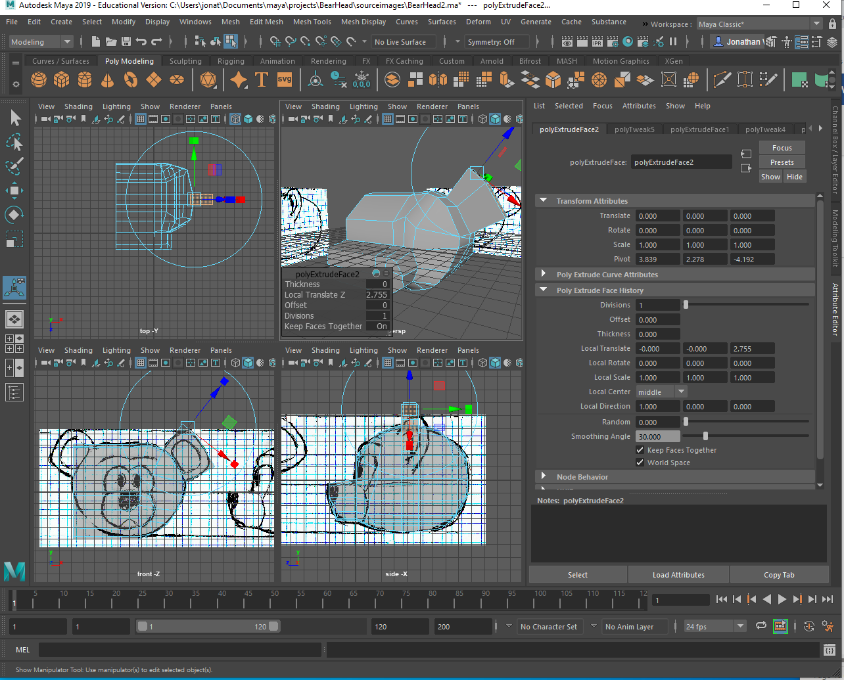
- and pull out the snout to the end of the nose as per the reference drawing for the side view (I deliberately selected the faces on the left because I do not want a face in the middle of the snout)
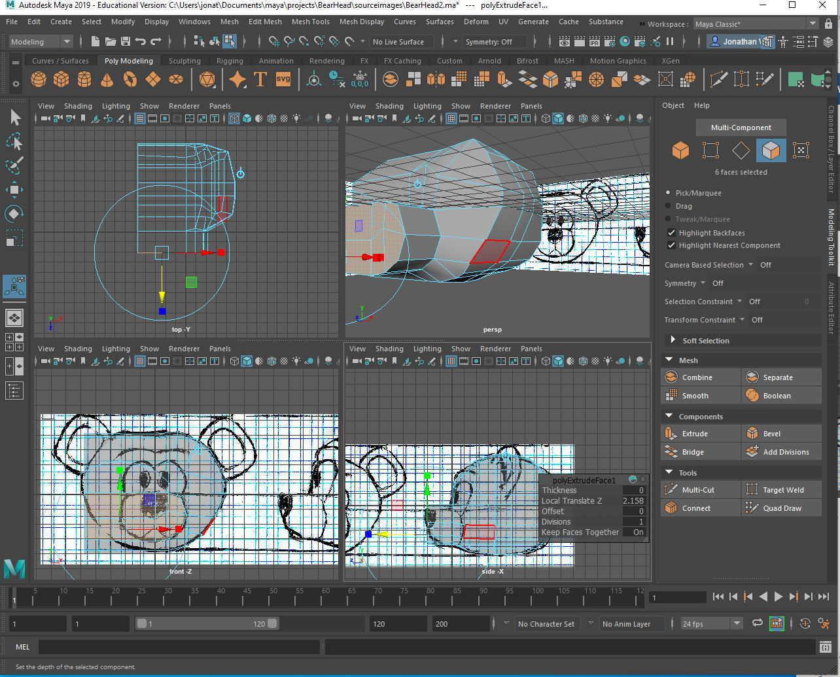
- Draw in the vertexes that are out of the lines, and make the snout a little more pointed.
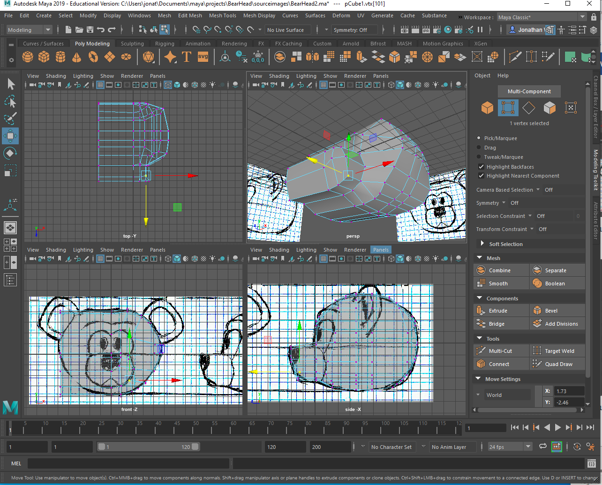
- Select the faces that make up the ears, extrude them (keep faces together is on), and pull them out (blue cone)
- Drop an edge loop around the middle of the ear, and move the vertexes to match the reference drawing.
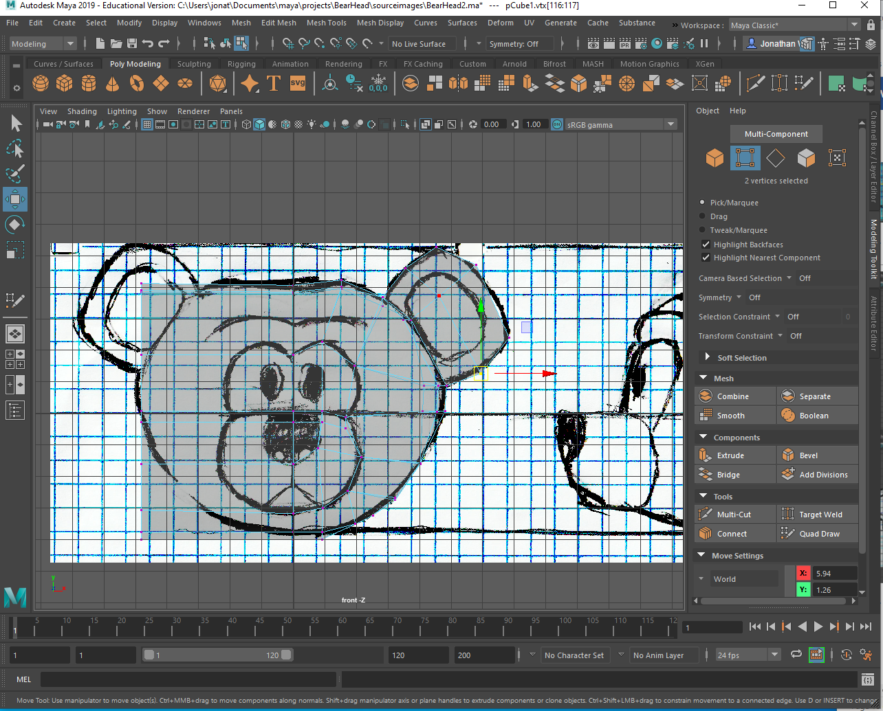
- Select the faces for the inside of the ear, Extrude (Crtl + E), and Resize (“R”) them to be a little smaller)
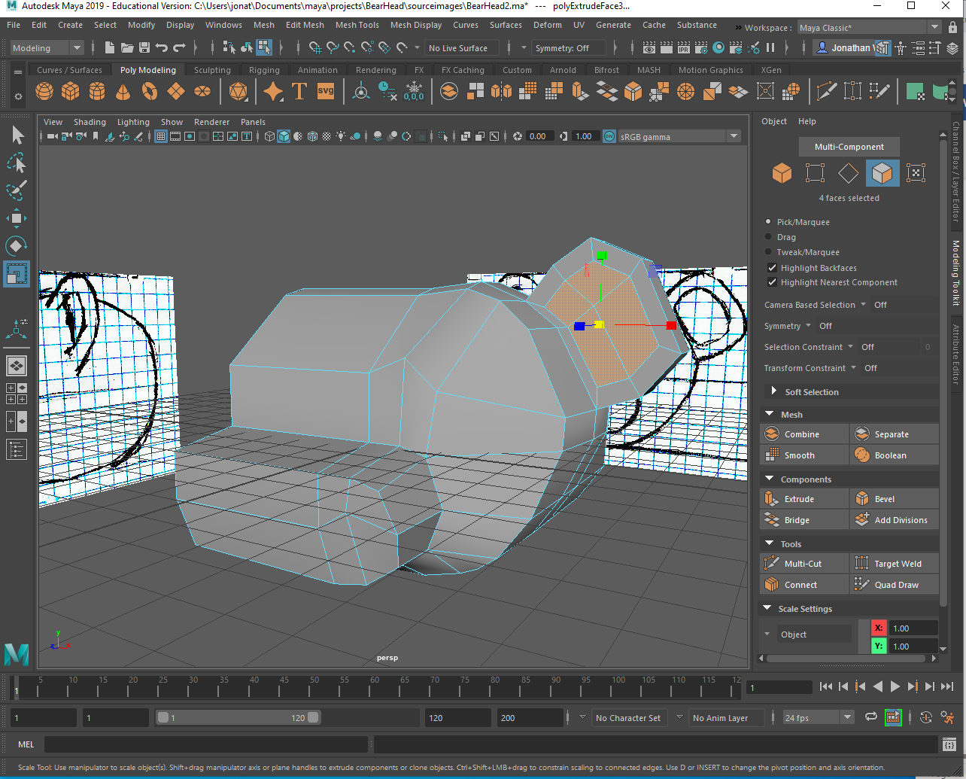
- Extrude again and move them back a little (hit “W” to move, and move the blue cone)
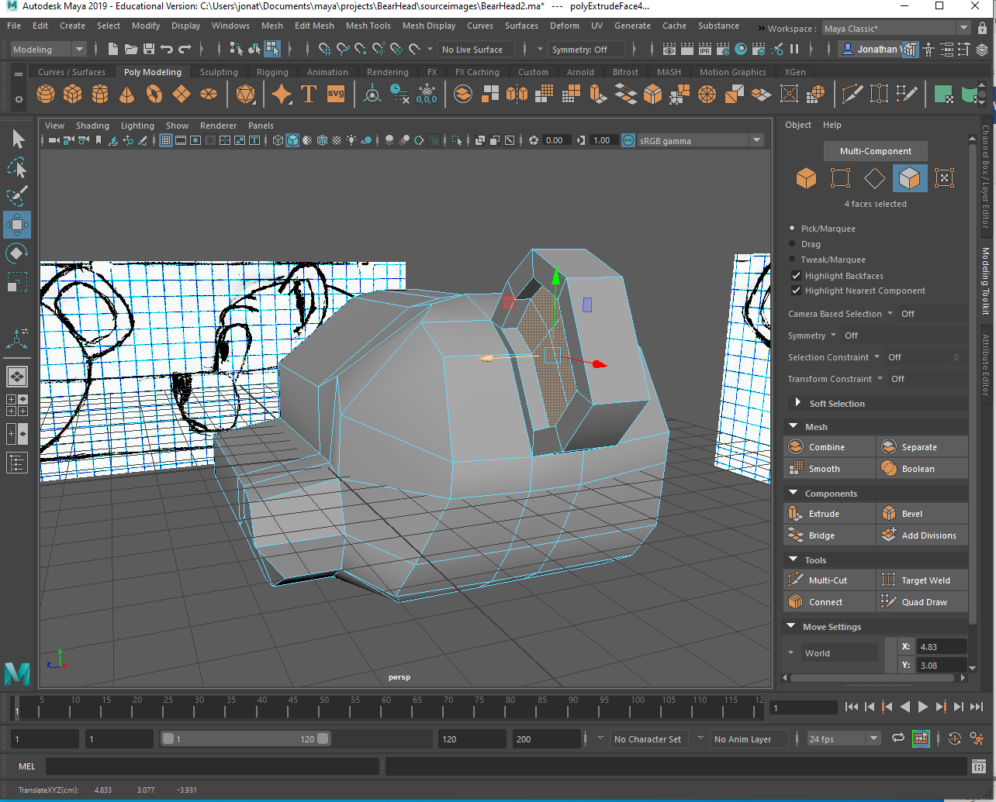
- Add a few more edge loops to give the nostrils some detail.
- 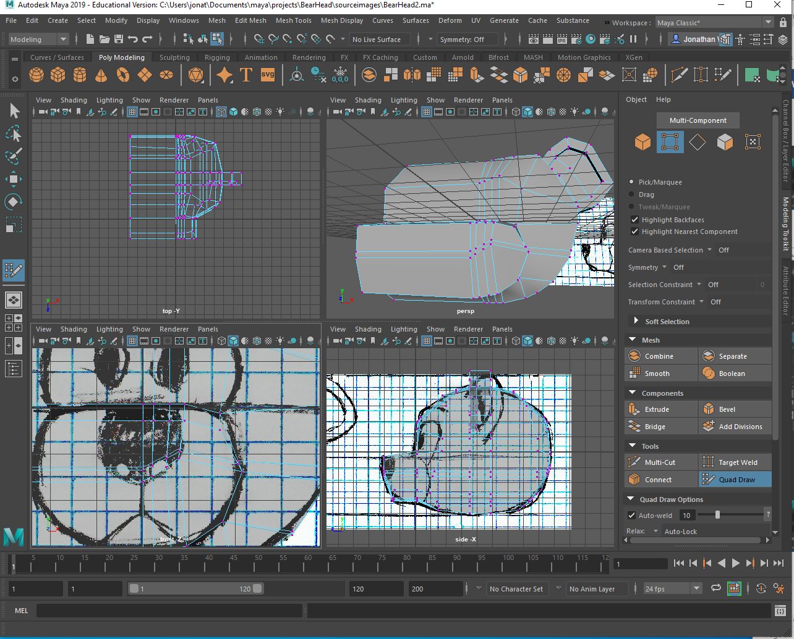
- Select the faces that make up the snout (and the faces connected on the side we will be deleting), extrude, and pull them out just a little
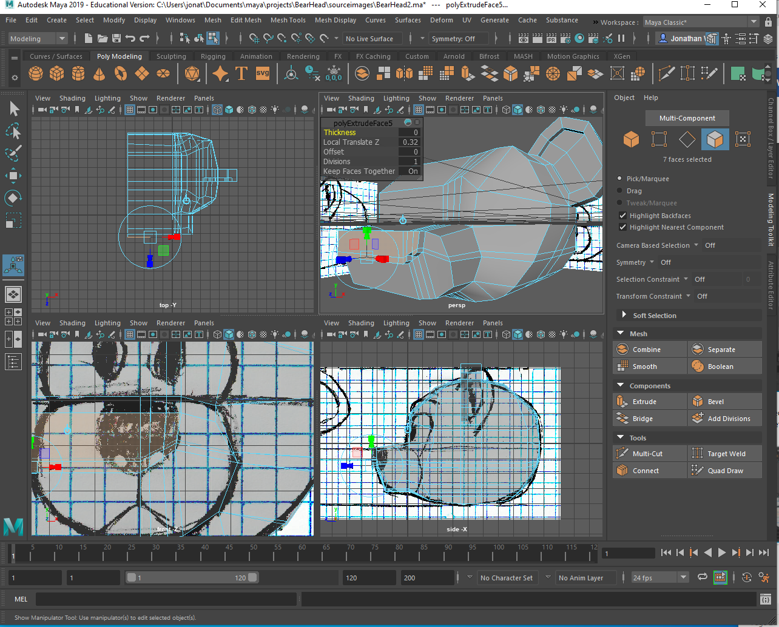
- Drop 2 edge loops near the bottom of the snout that will become the mouth
- 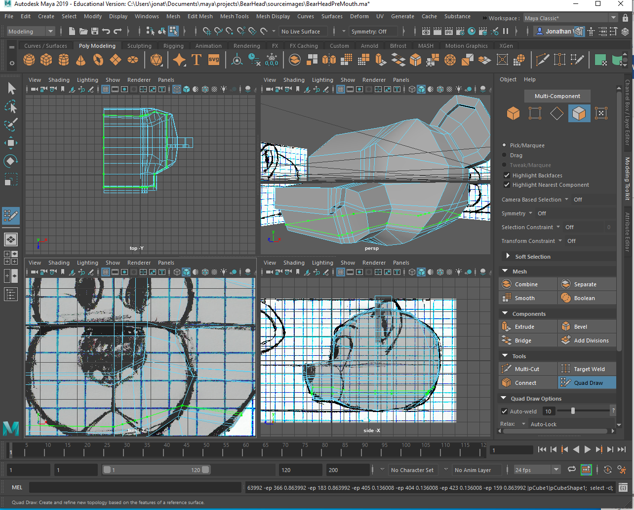
- Move the vertexes to follow the mouth lines
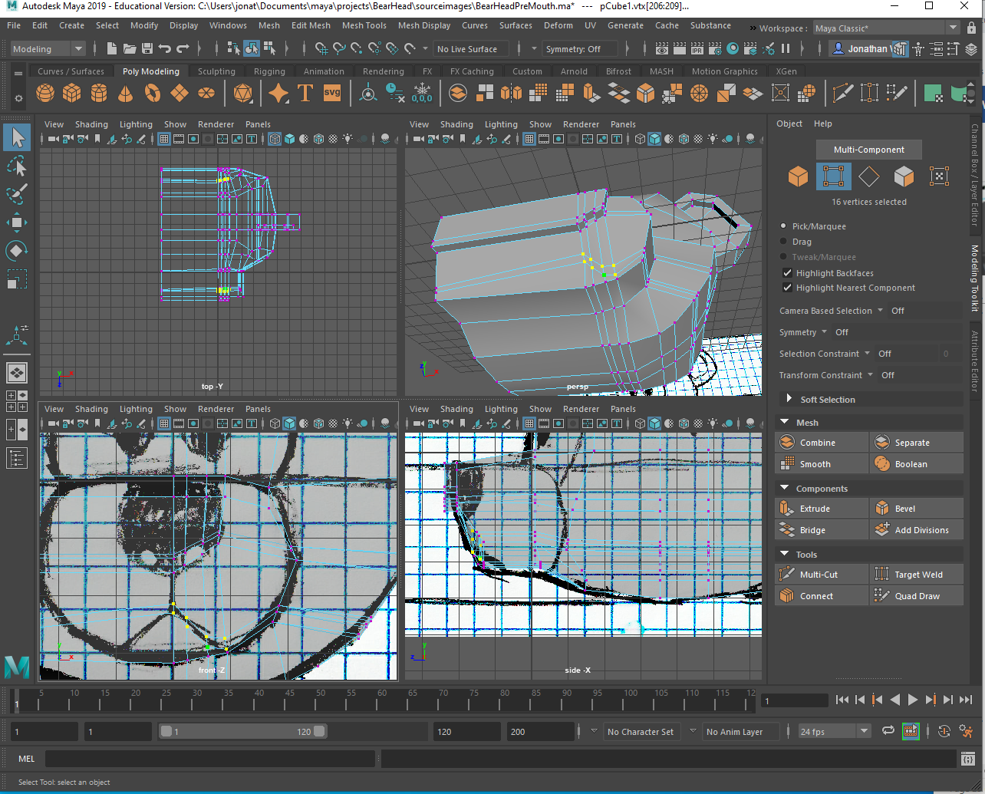
- Move the vertexes for the lower part of the mouth and chin in a little
- 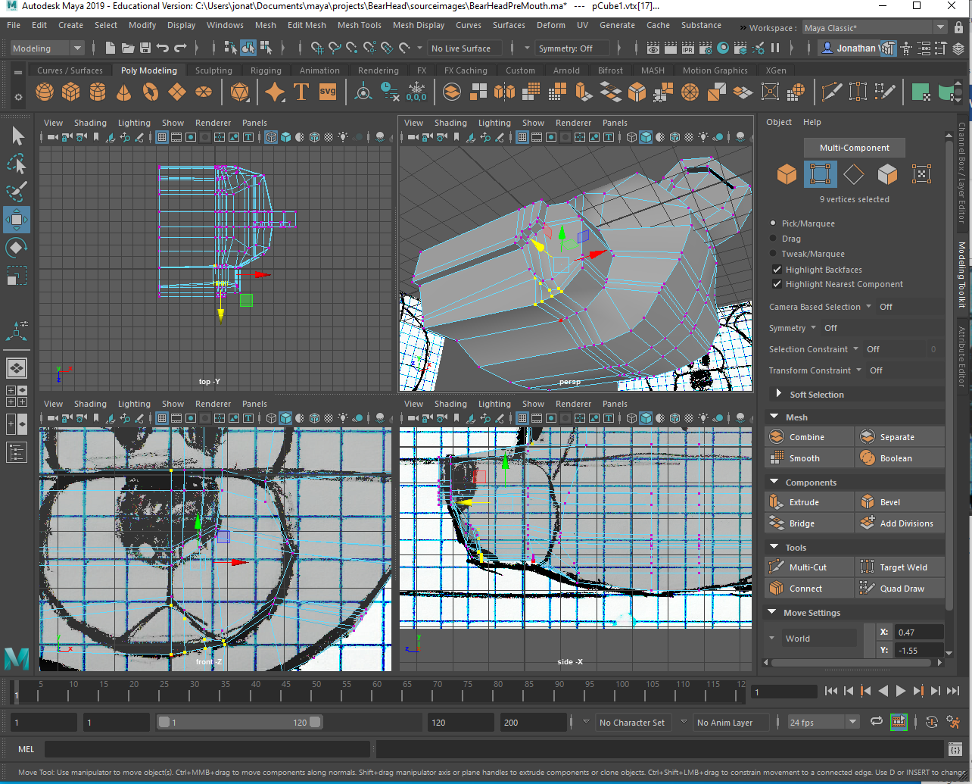
- Select the faces on the left side of the bear, and delete them

- Select the vertex on the tip of the nose, then shift + double click the next vertex back to select all the vertexes that should be aligned with 0 on the X axis
- 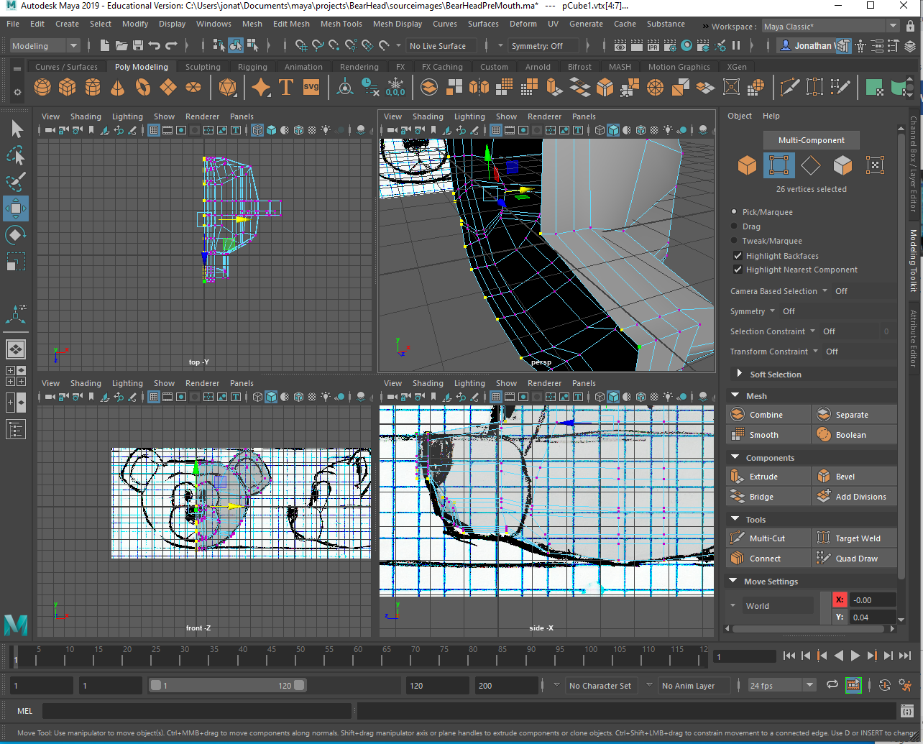
- Turn on “Snap to Grid” (the magnet next to the grid at the top)
- Double Click on the “Move Tool”, the tool settings will come up
- Open the “Move Snap Settings” make sure “Retain Component Spacing” is still deselected
- Hit “W” and move the X axis handle cone (do not grab the middle of the move tool), and move the vertices to the left one square and back to the 0 axis. (This step aligns the vertices along the middle of the object)
- 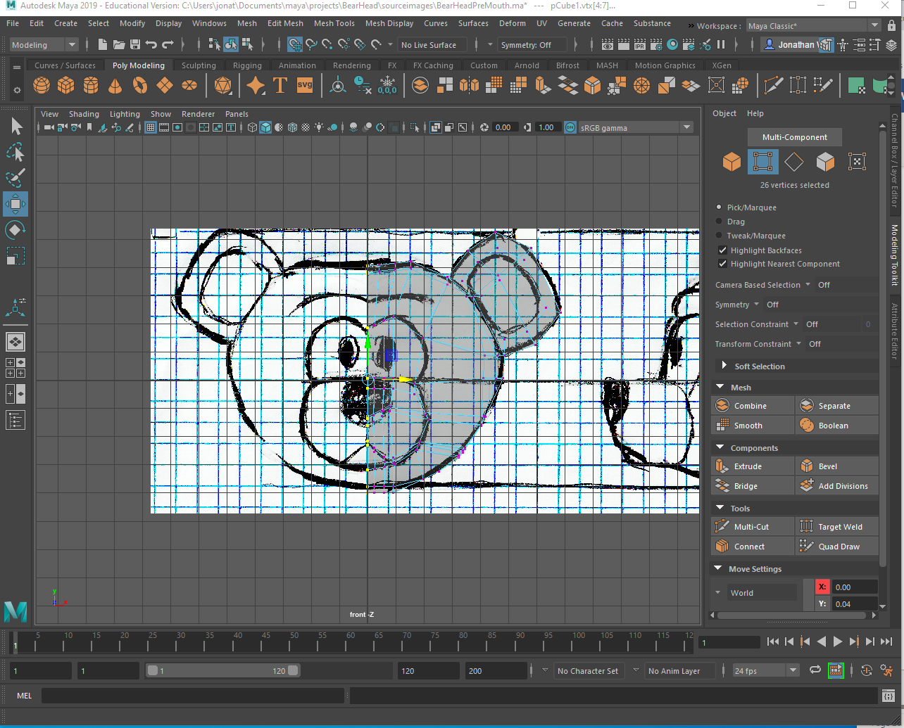
- Right click on the object, go into “Object Mode”, and select the object
- Go to “Mesh” (at the top) and click on the square to the right of “Mirror” to pull up the mirror options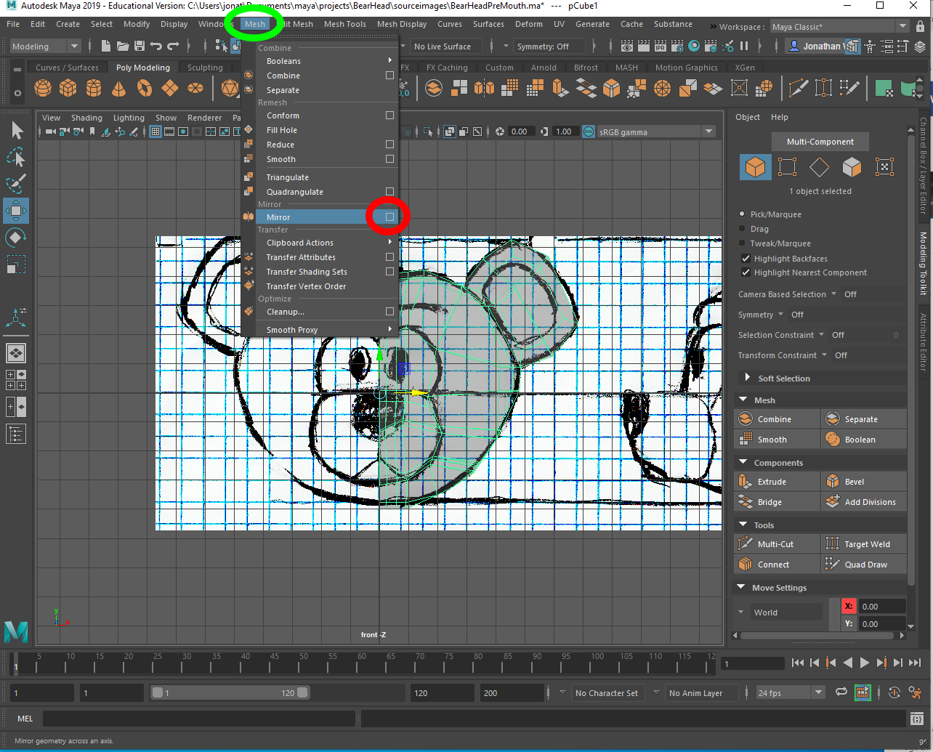
- Make sure the mirror axis is on “X” and “-”
- 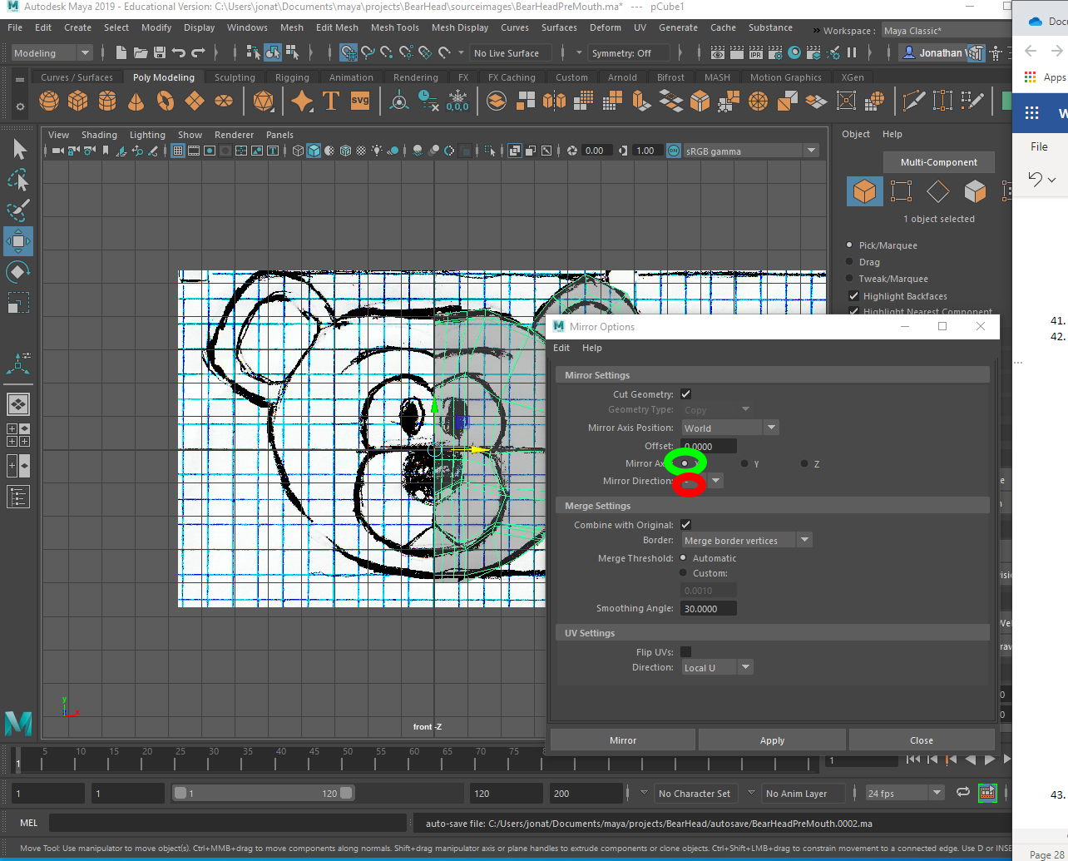
- Make sure “Cut Geometry” is off
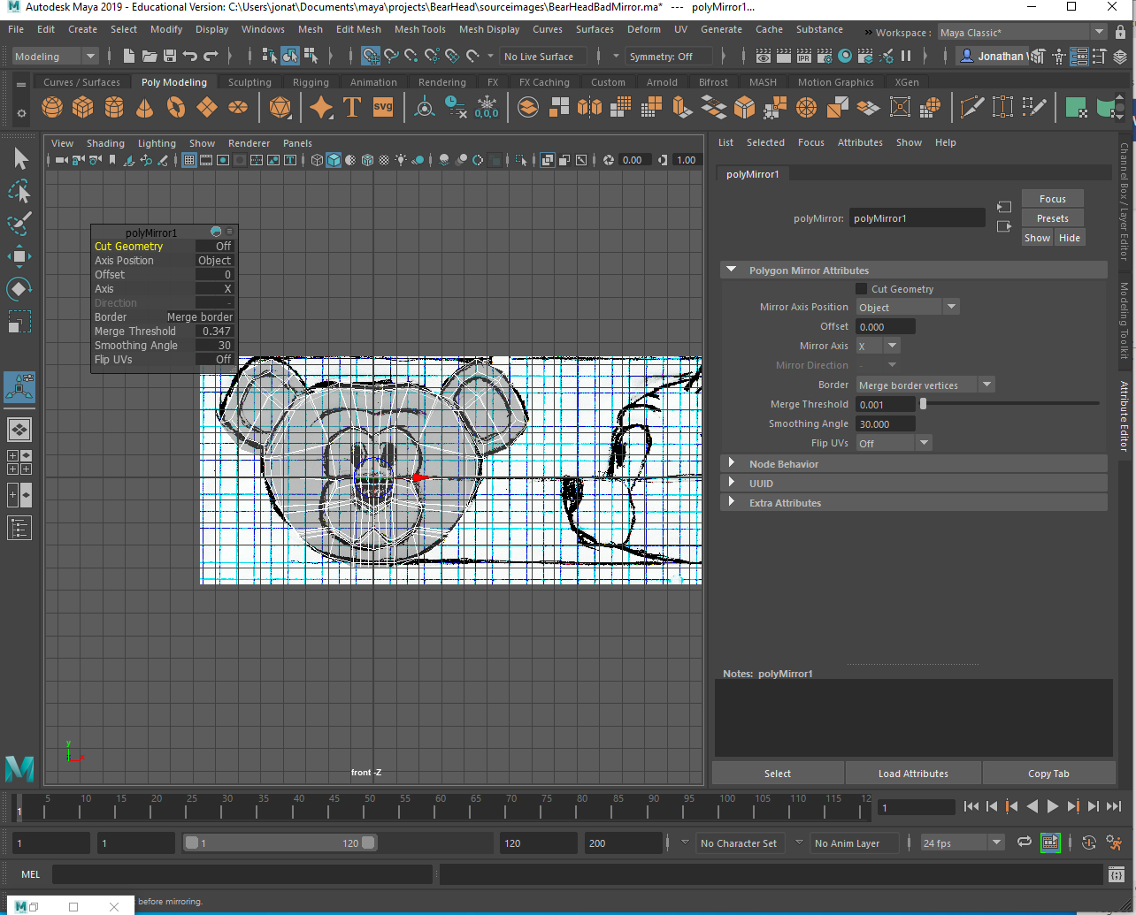
- Go to “Mesh” (at the top) and select “Smooth”
- 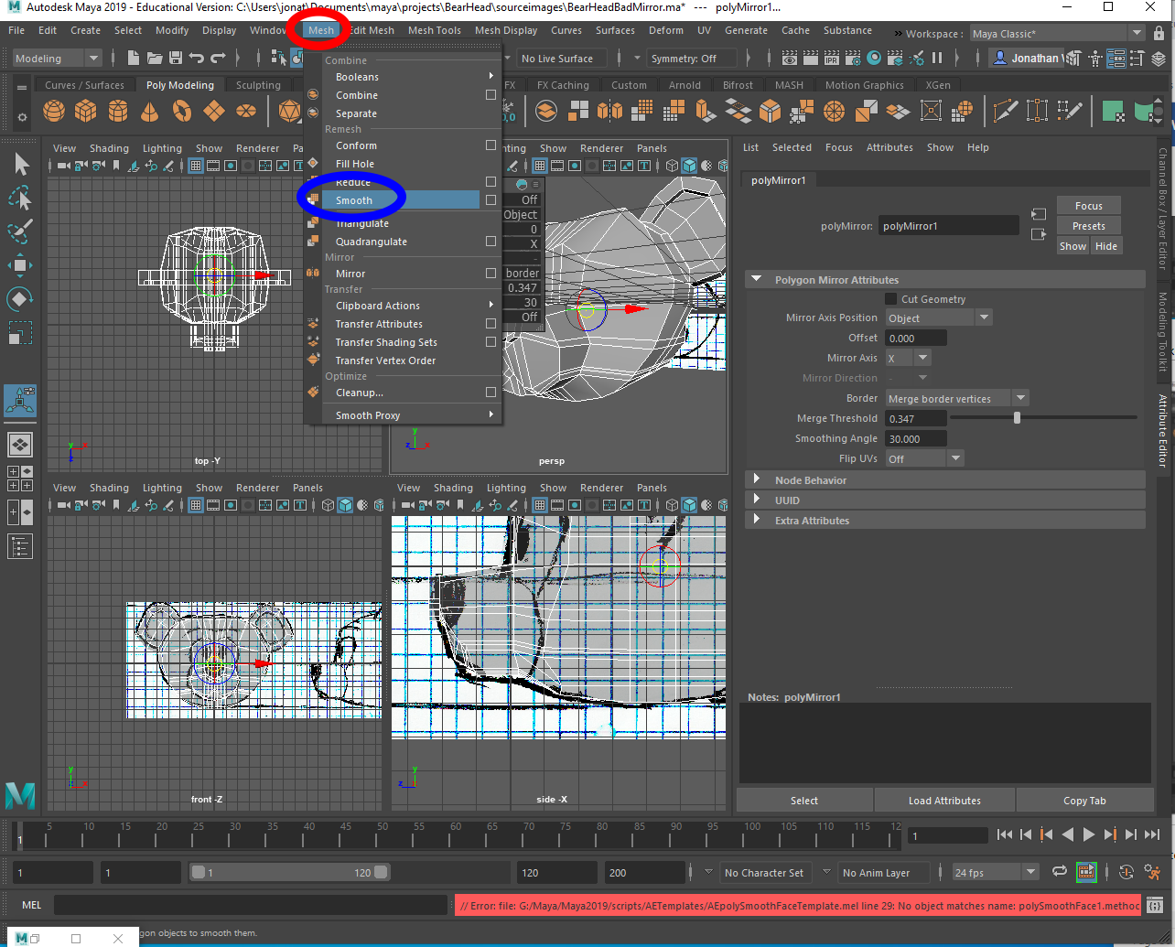
- Go to “Edit” (at the top), “Delete all by Type”, and select “Non-Deformer History”
- Save it

